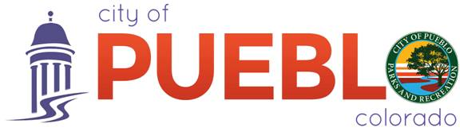
PRESS RELEASE

August 8, 2016

TO: News Editor
FROM: City of Pueblo
Pueblo Parks and Recreation
www.puebloparks.us
CONTACT: Nathaniel Evans
Volunteer Coordinator
719-553-2810
nevans@pueblo.us

Pokémon Go Clean up Your Town

In an effort to curtail the recent negative views of Pokémon Go, a new volunteer group has arisen to present a more positive image of the popular game and its players: Pokémon Go Clean up Your Town. Created by Jebus James Robert William Murphy, along with a local business, Chaos Games and More and supported and assisted by the Pueblo Parks and Recreation Volunteer Program, this enthusiastic group in one week hosted two clean-ups, one at the river walk and the other at Pueblo City Park. They recruited over 50 new volunteers.

Continuing its efforts, Pokémon Go Clean up Your Town, has clean-ups scheduled throughout the rest of the year at various locations around the city. Please contact the Pueblo Parks and Recreation’s volunteer coordinator at 719-553-2810 or Jebus at 719-248-2827 for more information on this volunteer group.

###
THE CITY OF PUEBLO IS AN EQUAL OPPORTUNITY EMPLOYER

