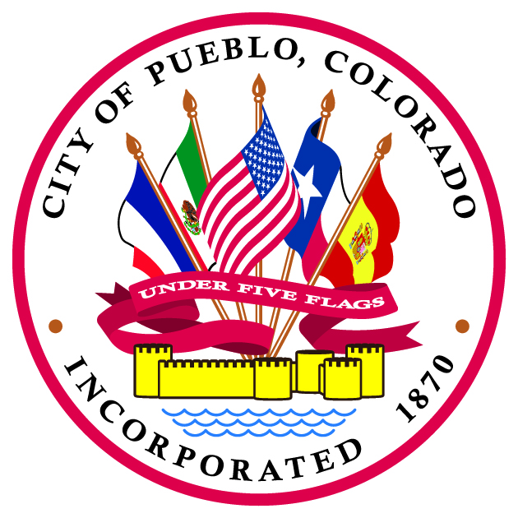
NOTICE OF MEETINGS
OF THE PUEBLO CITY COUNCIL

THE PUEBLO CITY COUNCIL WILL MEET FOR THE PURPOSES DESCRIBED IN THIS NOTICE.

CITY COUNCIL DINNER

THREE OR MORE CITY COUNCIL MEMBERS MAY GATHER FOR DINNER ON MONDAY, JULY 25, 2022 COMMENCING AT 4:30 P.M., PRIOR TO THE WORK SESSION, IN THE EXECUTIVE SESSION CONFERENCE ROOM, THIRD FLOOR, CITY HALL, ONE CITY HALL PLACE, PUEBLO, COLORADO 81003.

CITY COUNCIL WORK SESSION

A PUEBLO CITY COUNCIL WORK SESSION WILL BE HELD ON MONDAY, JULY 25, 2022 COMMENCING AT 5:30 P.M. IN THE CITY COUNCIL CHAMBERS, THIRD FLOOR, CITY HALL, ONE CITY HALL PLACE, PUEBLO, COLORADO 81003.

CITY COUNCIL REGULAR MEETING

A PUEBLO CITY COUNCIL REGULAR MEETING WILL BE HELD ON MONDAY, JULY 25, 2022 COMMENCING AT 7:00 P.M. IN THE CITY COUNCIL CHAMBERS, THIRD FLOOR, CITY HALL, ONE CITY HALL PLACE, PUEBLO, COLORADO 81003.

